**Steps for Creating A Pull Request:**

**Step 1:** We can either clone the repo and edit contents using Git Bash or Fork the Repository and edit files on GitHub.

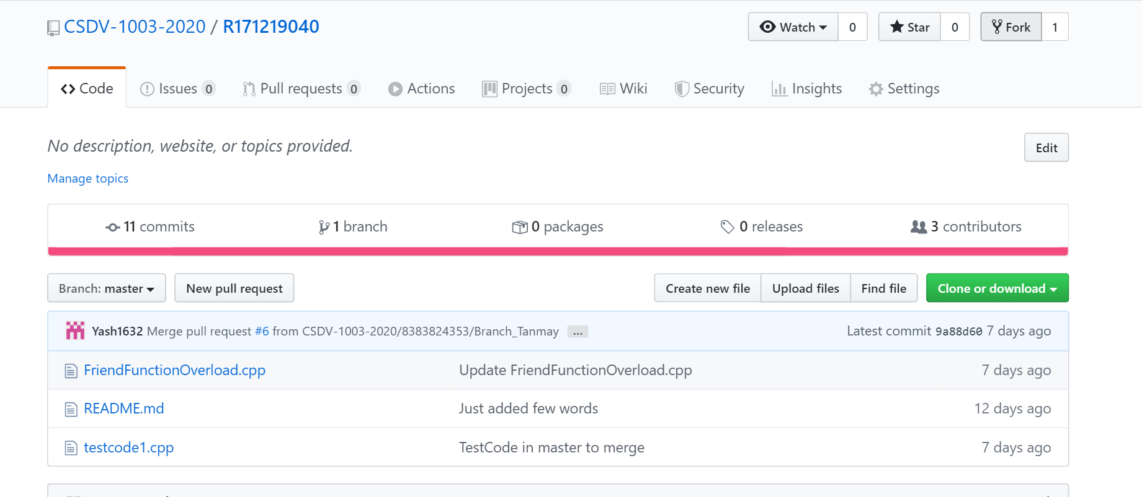

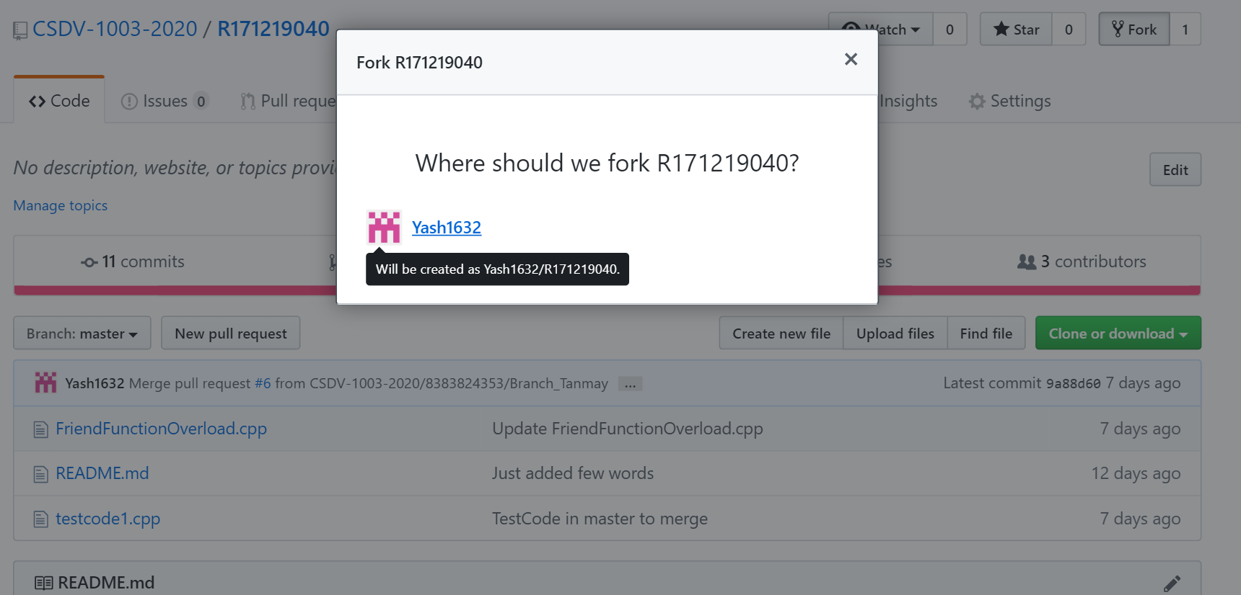

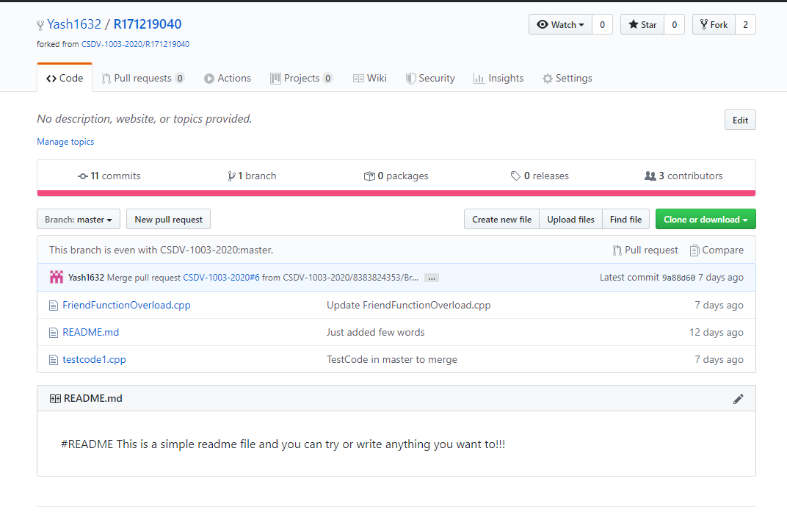

**Step 2:** After committing changes to forked repo, choose compare changes option to compare changes to original organizational repo.

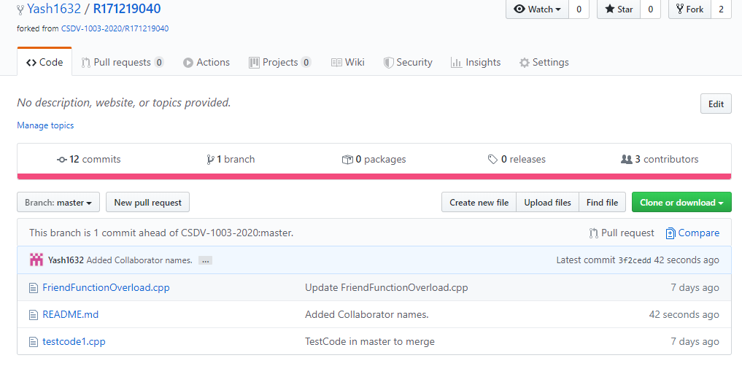

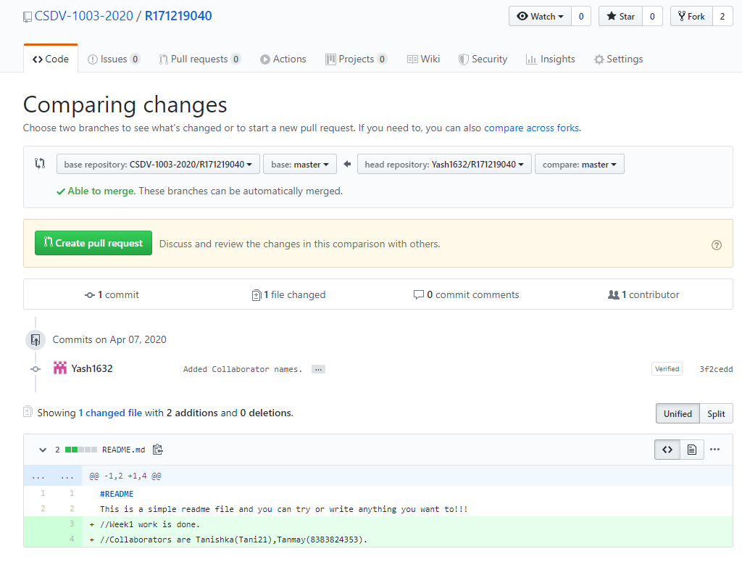

**Step 3:**  Click **Create Pull Request** and wait for the repo manager or admin to check changes and accept or reply in comments.

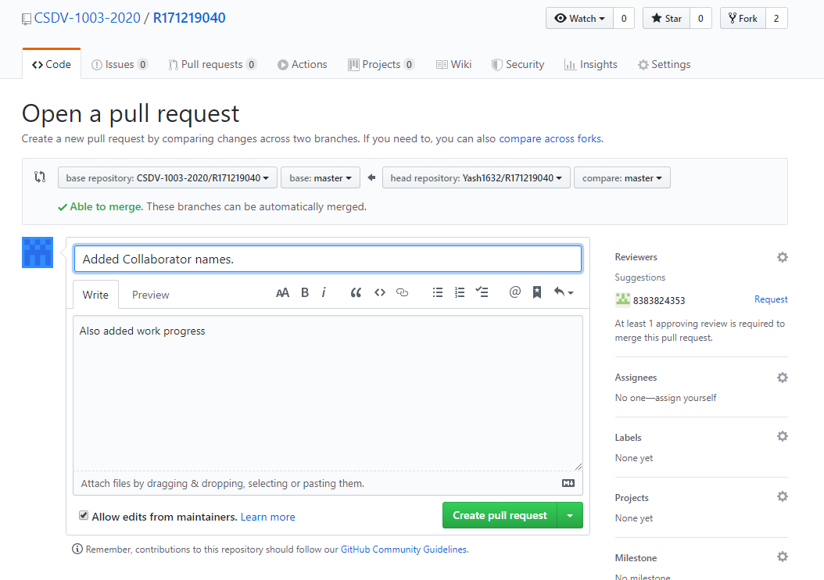

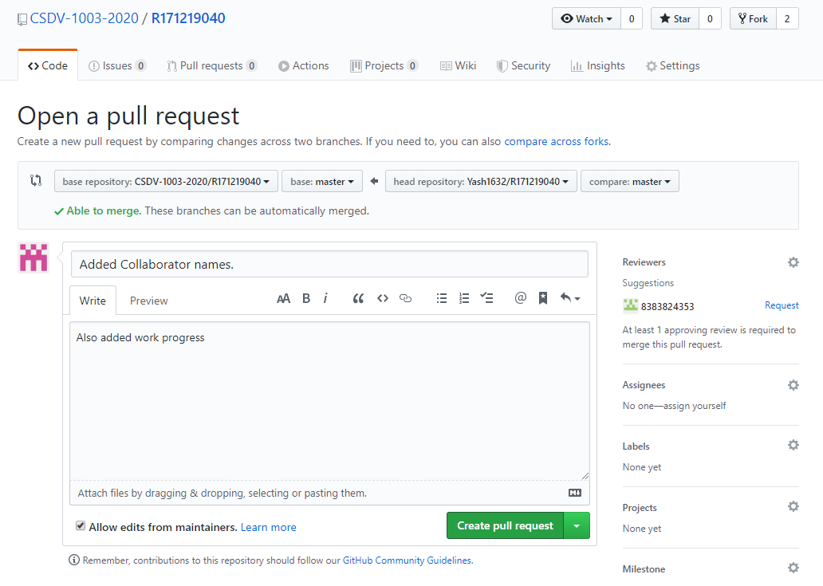

After Pull Request is created, it is shown under the pull requests tab in the repo.

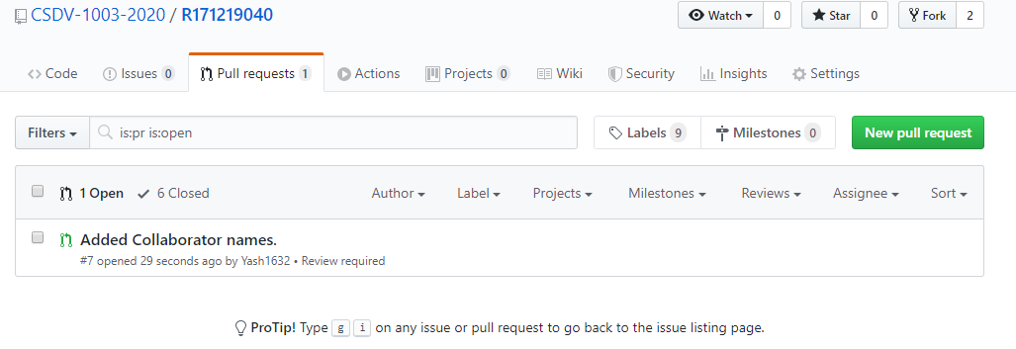

**Steps for accepting a pull request:**

**Step 1:** A pull request is created by collaborator to merge changes to master branch.



**Step 2:** Check for the modifications collaborator has made.

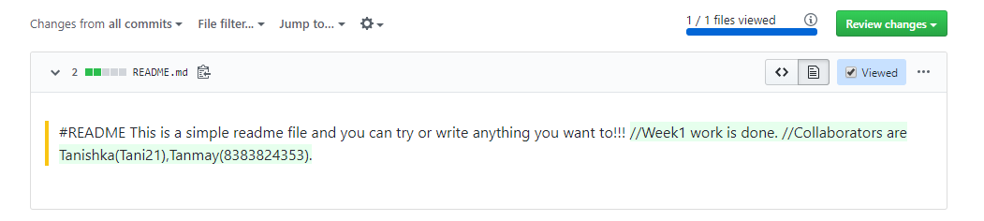

**Step 3:** Merge the pull request created by collaborator by clicking on merge pull request. After pull request is merged, it is automatically closed and the edited code is merged with the master branch and latest commit is updated to the one added while merging.

